Atlantian Baronial Electronic Polling
- Go to polling.atlantia.sca.org
- The AEL account is the same you use for Atlantian University or for polling orders. Use the left menu to Login or Request an Account if you need one.
- Switch to Baronial Pollings.
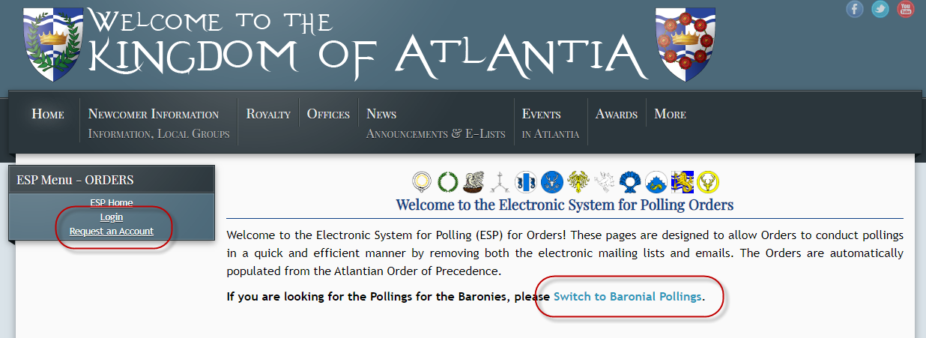
- If your membership has not been connected to your AEL you will see this message:
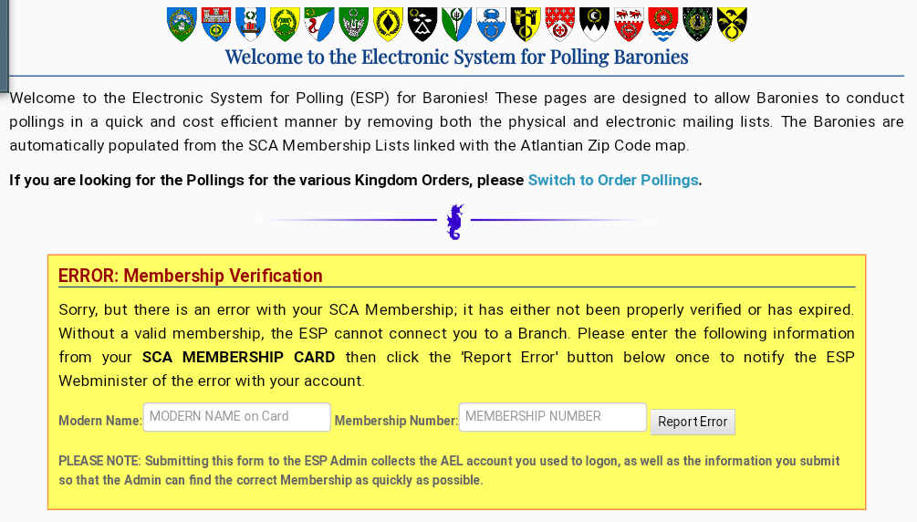
Enter your Modern Name and Membership Number and Click “Report Error” A member of the Atlantian Web Team will confirm your membership and link it. They will email you when complete.
- Change your polling type to Electronic. (Default is paper, electronic is opt-in.)
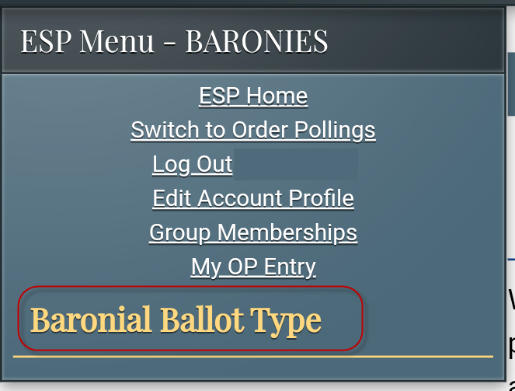 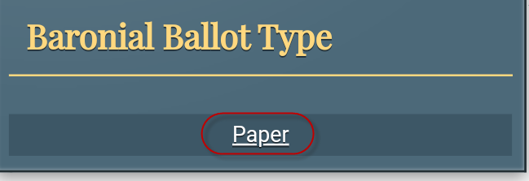
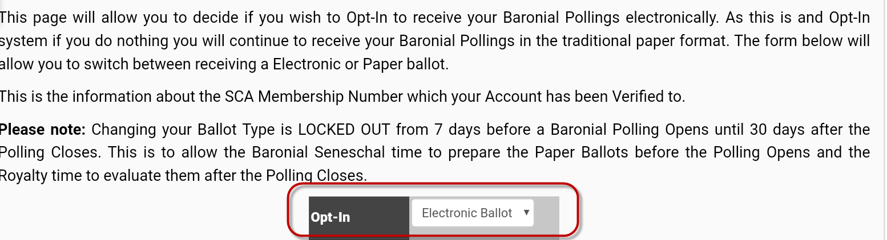
Click “Baronial Ballot Type” then click the word “Paper”, then change to “Electronic Ballot” at the opt-in box in the center of the screen.

